

**School of Information Technology**

**Diploma in Cybersecurity and Digital Forensics**

*2021-S2*

**IT2566 InfoSecurity Project**

# Annex C: Individual Project Report

|  |  |  |  |
| --- | --- | --- | --- |
| **Student’s**  **Name** | Dennis Ng Han Jie | **Admin No** | 204461H |
| **Course** | Diploma in Cybersecurity and Digital Forensics | **Acad / Sem** | 2021 S2 |
| **Module Name** | IT2566 InfoSecurity Project | **Module Group** | SF200_ |
| **Module**  **Supervisor** | Mr Vincent Phua |  |  |
| **Team Leader** | Soh Jun Rong, Nicholas | **Team Name** | McSpicy |

## Instructions:

(i) Each team member shall submit one form to Blackboard.

## 1. Project Description

Our targeted users would be the law enforcement agencies, specifically the Singapore Police Force.

The purpose of this application is to provide law enforcement officers with a secure and reliable web portal that allows them to safely exchange information and communicate with one another. The police will be able to search and submit evidence case files securely, search for particulars regarding a suspect, and communicate through our secure email system.

## 2. Individual Task

**Django Multiple Database**

* Instructs each application in the Django project which database to use.
* Created routers.py
  + Use route_app_labels in routers.py
  + Add all routing methods in routers.py
  + Add app_label in models.py
* Configure settings.py
  + Add all databases configurations
  + Add database routing

**Criminal records CRUD**

* Allow users to add, read, update, and delete criminal records into the database
* Create models.py for criminal records SQL database table
* Edit urls.py to include all views in the views.py
* Create views.py for the CRUD
* Forms template created using crispy forms
  + {{ forms | crispy }} in the HTML template

**CSRF Token**

* Add {% csrf_token %} after every <form> tag in the HTML

**Input validation for Criminal Records, Wanted List and Case Investigations (1 week)**

* Add validation methods into the forms.py
  + Use regex pattern for input validation
  + **Criminal Records**
    - Name: ^[a-zA-Z ]+$
    - NRIC: ^[STFG]\d{7}[A-Z]$
    - Charges: ^[a-zA-Z ,]+$
    - Gender: ^[M|F]$
    - DOB: ^\d{4}-[0-3][0-9]-[0-3][0-9]$
  + **Wanted List**
    - Name: ^[a-zA-Z ]+$
    - NRIC: ^[STFG]\d{7}[A-Z]$
    - Wanted For: ^[a-zA-Z ]+$
    - Date added: ^\d{4}-[0-3][0-9]-[0-3][0-9]$
  + **Case Investigations**
    - Case Name: ^[a-zA-Z ]+$
    - Status: ^[a-zA-Z]+$
    - Officers: ^[a-zA-Z ,]+$
    - Description: ^[a-zA-Z \d,.]+$
* If regex pattern doesn’t match, raise ValidationError
* Using Django’s form.is_valid() method to check the form inputs against the validation methods

**Security Headers**

* Configuration done in settings.py
* **XSS Protection**
  + SECURE_BROWSER_XSS_FILTER = True
* **Strict Transport Security (Load website on HTTPS only)**
  + SECURE_HSTS_SECONDS = 1800
  + SECURE_HSTS_INCLUDE_SUBDOMAINS = True
  + SECURE_HSTS_PRELOAD = True
* **MIME Sniffing Protection**
  + SECURE_CONTENT_TYPE_NOSNIFF = True
* **Clickjacking Protection**
  + X_FRAME_OPTIONS = ‘Deny’
* **Referrer Policy**
  + SECURE_REFERRER_POLICY = ‘same-origin’
* **Content Security Policy**

**Email Server**

* Using hMailServer and a VM
* VM hosted on Azure
* Self-signed SSL Certificate
  + Installed OpenSSL
  + TLS / SSL encryption
* Authentication required to use email server

**ClamAV**

* ClamAV antivirus scanning for email attachments
* Not implemented on the cloud-hosted VM that is integrated with the rest of the other members’ features as it has only 2 GB of RAM and ClamAV requires at least 3 GB of RAM

**Web-Based Email Client**

* Users can send and view messages with attachments
* Using IMAP and SMTP connection
* TLS encryption

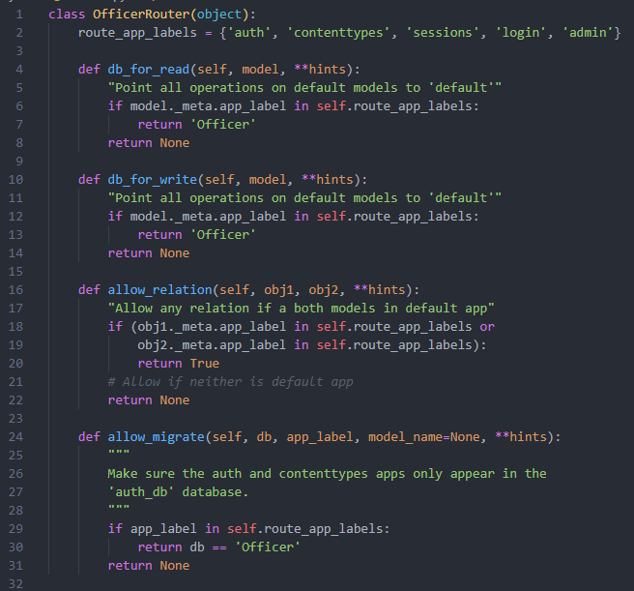

Figure Routers.py

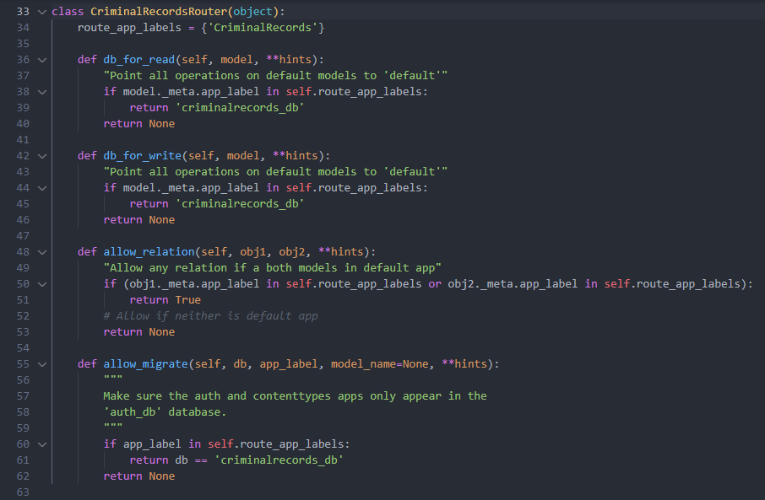

Figure Routers.py

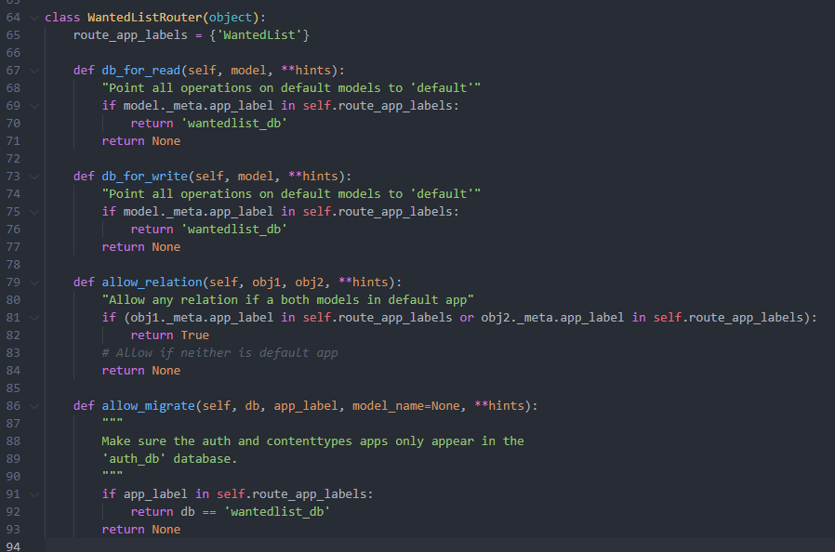

Figure Routers.py

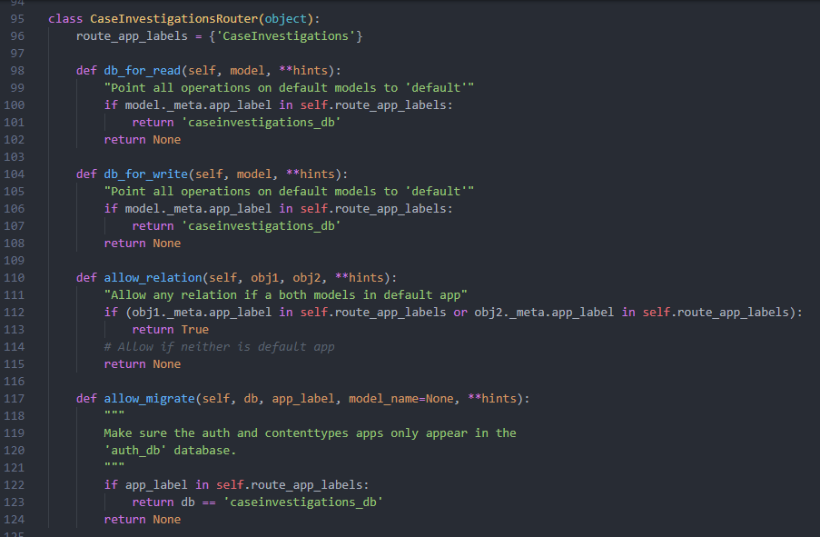

Figure Routers.py

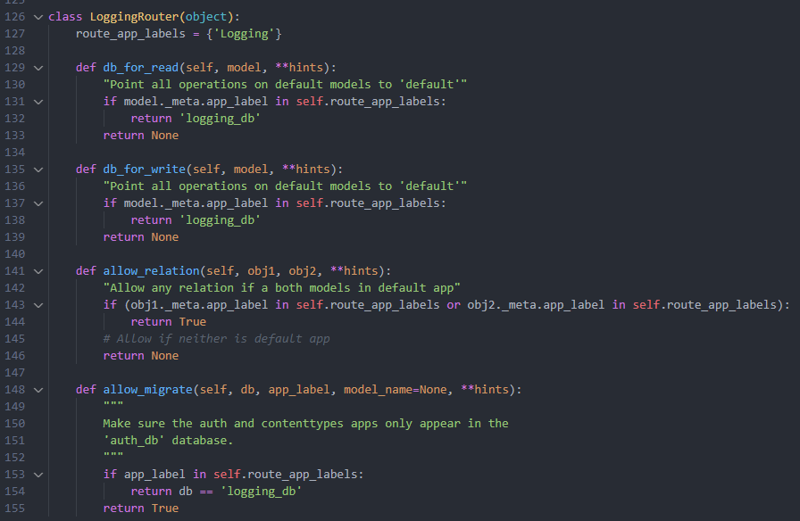

Figure Routers.py

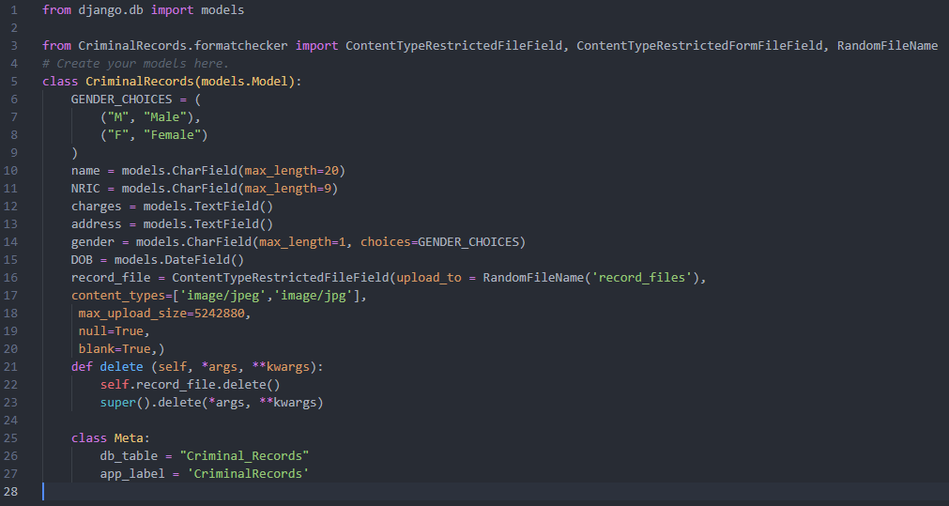

Figure Models.py

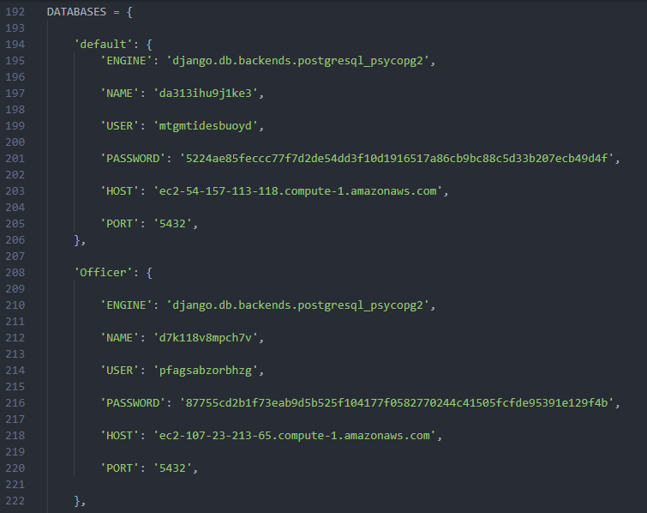

Figure Settings.py

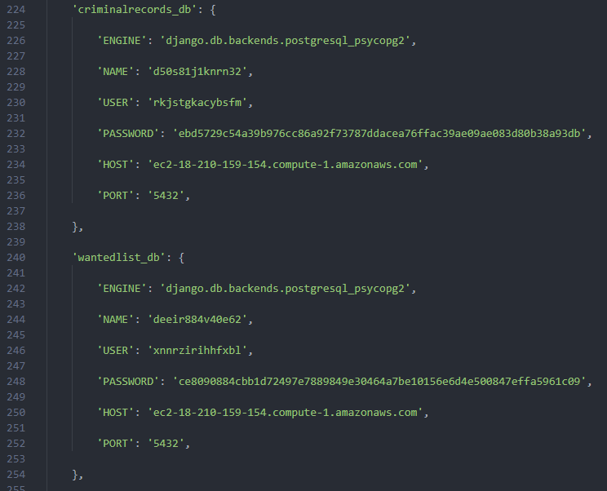

Figure Settings.py

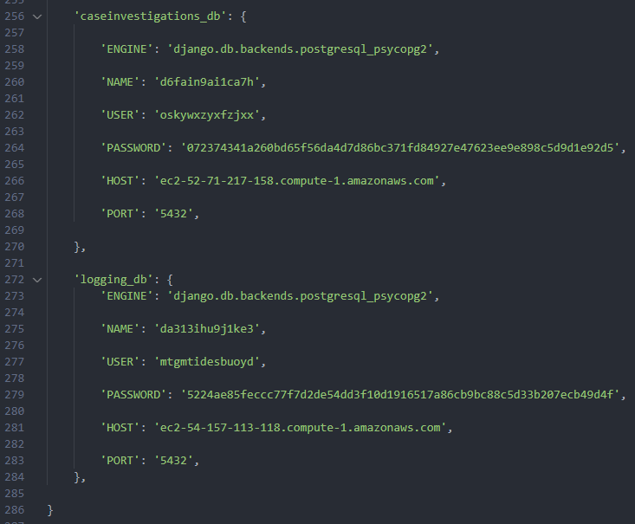

Figure Settings.py

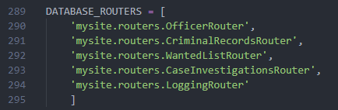

Figure Settings.py

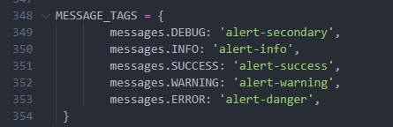

Figure Settings.py

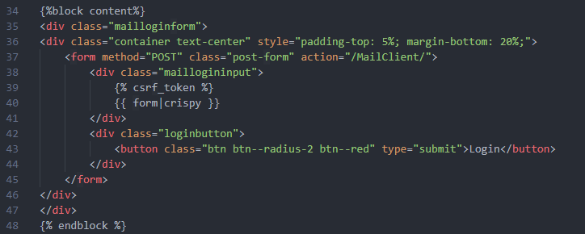

Figure Mallogin.html

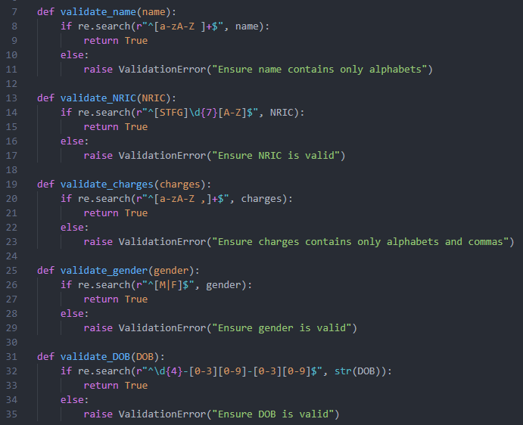

Figure Forms.py validation

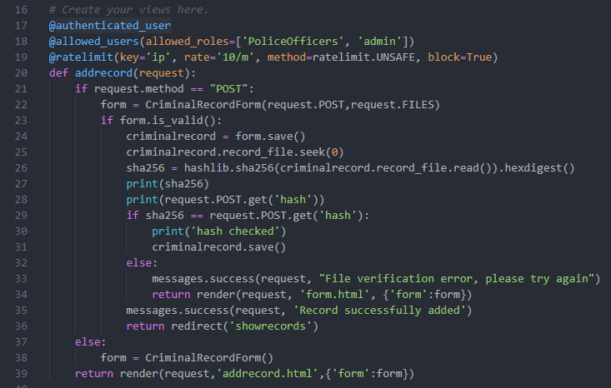

Figure Views.py for Criminal Records

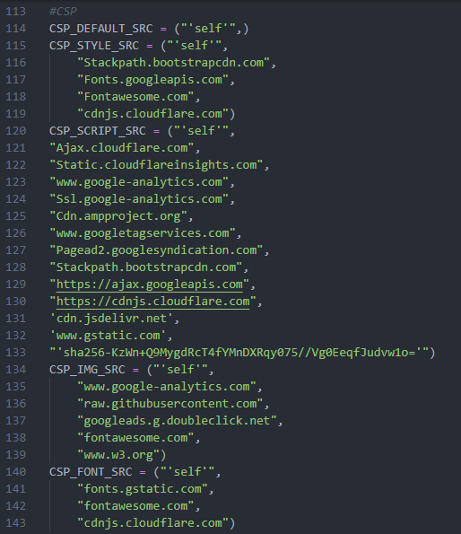

Figure Settings.py CSP

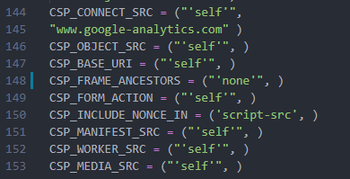

Figure Settings.py CSP

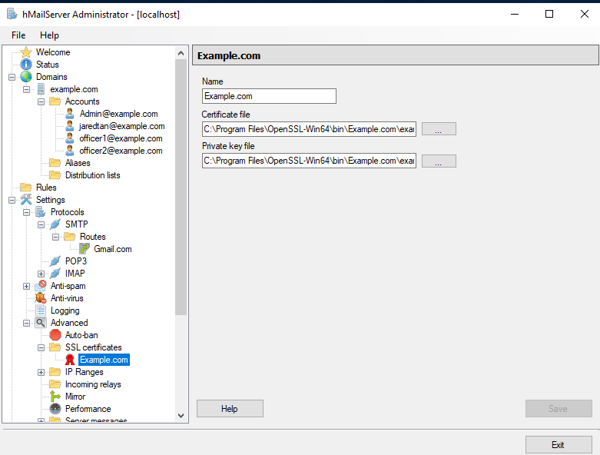

Figure hMailServer SSL Certificate

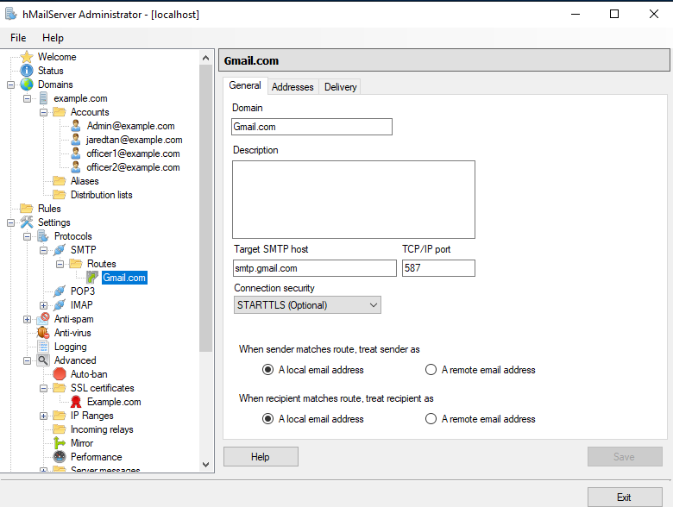

Figure hMailServer Gmail Route

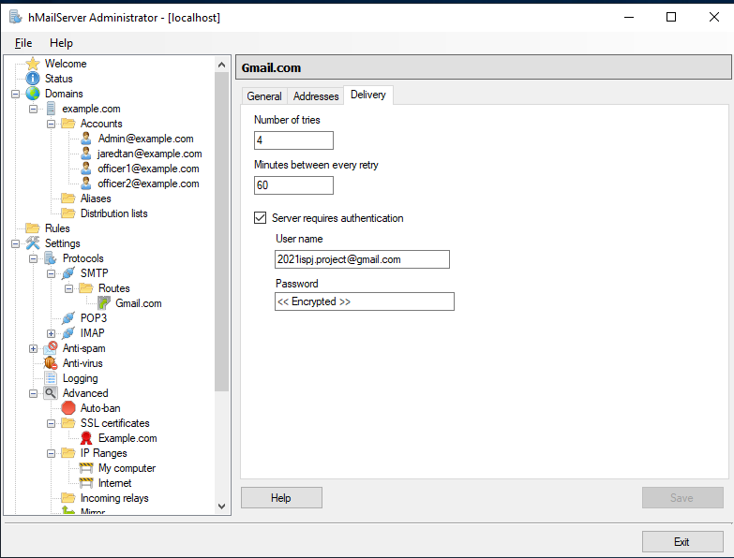

Figure hMailServer Gmail Route

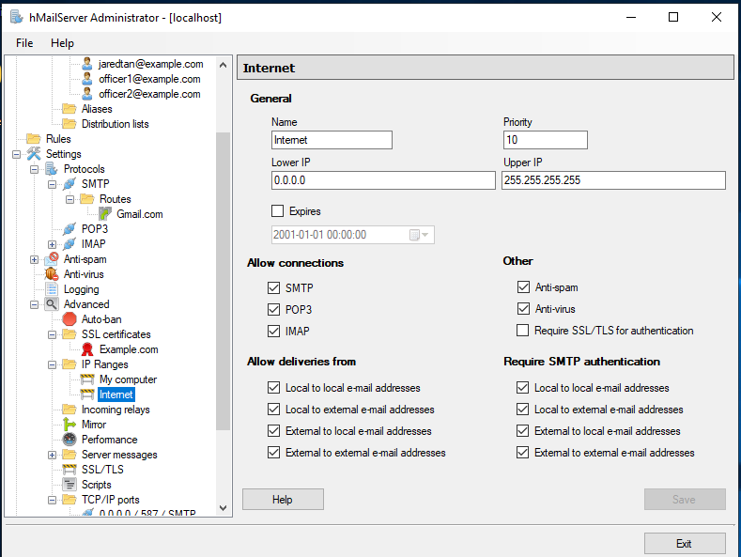

Figure hMailServer Gmail Authentication

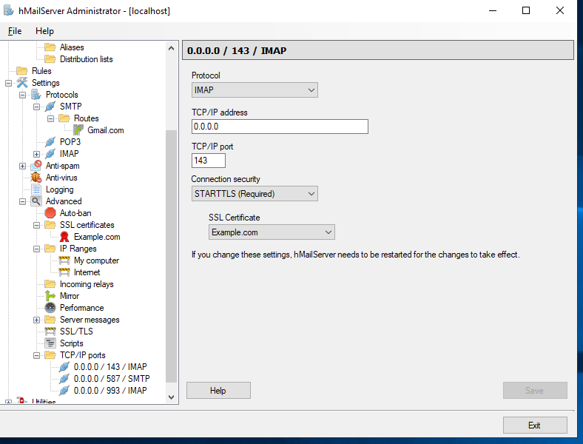

Figure hMailServer IMAP Port 143

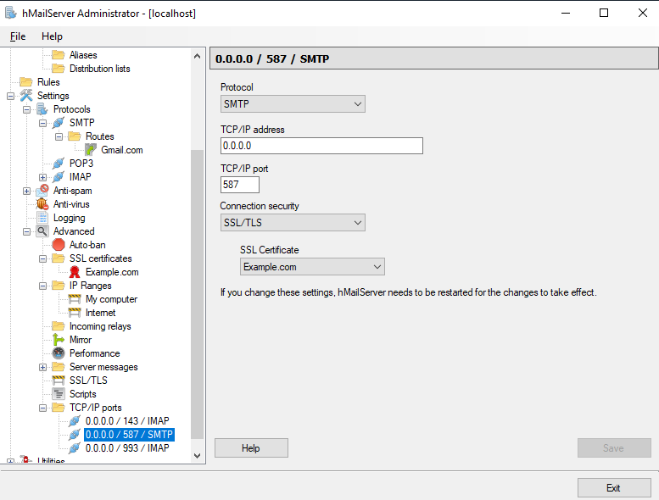

Figure hMailServer SMTP Port 587

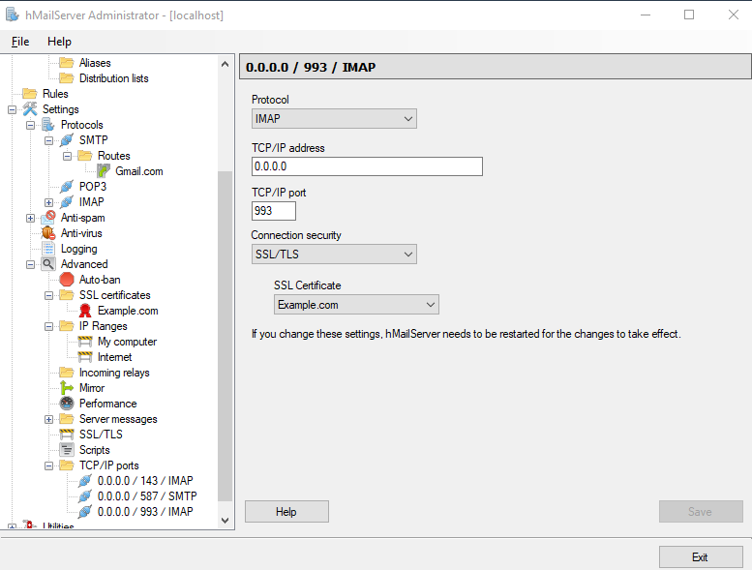

Figure hMailServer IMAP Port 993

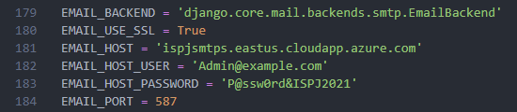

Figure Settings.py Email Connection

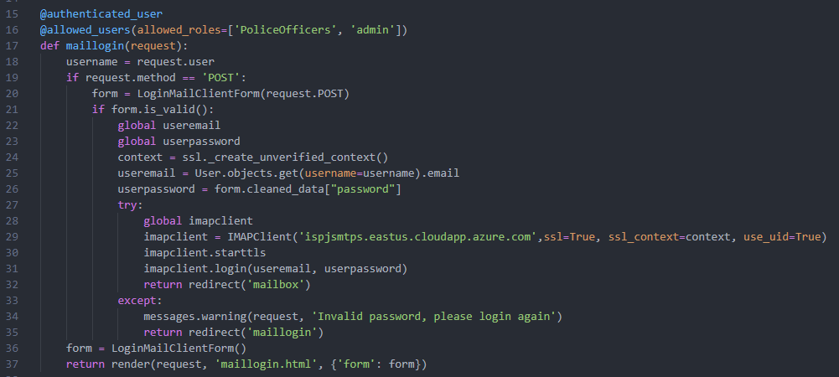

Figure Mail Client views.py Login

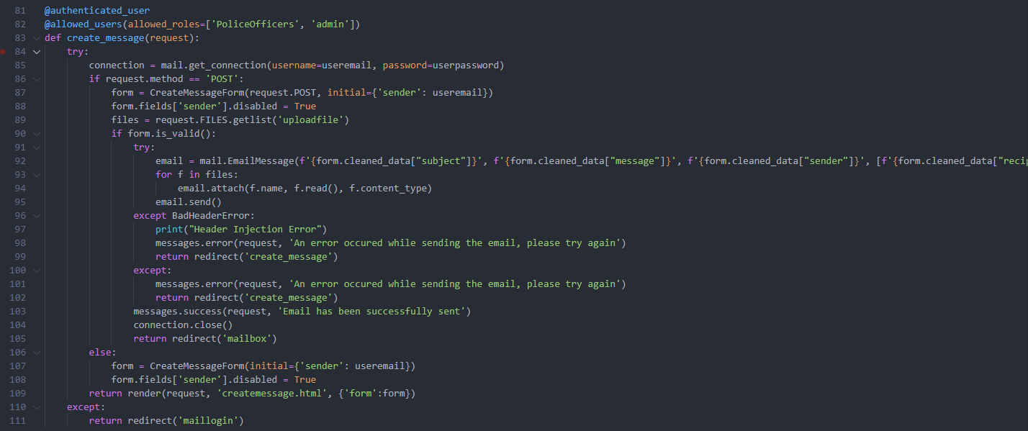

Figure Mail Client views.py Create Message

## 3. Other Individual Contributions and Reflection

<Any contributions that you think will give you credit, e.g. team leader, integrator, innovation, challenges, self-learnt technical areas, etc.>

Learnt a new python framework, Django

Helped in troubleshooting some of the other members’ features

Difficulty in setting up of email server as there were not much documentation, and had to re-configure the email server from scratch and added more security implementations as it was hacked in the past.

Django multi-database routing and configuration as there were not much documentation as it is out of the norm for Django users since usually, they only have one database.

Troubleshooting of connection issues with IMAP and SMTP along with the issues that were raised by implementing TLS.

Teaching other members on how to use the multi-database routing and configuration.

## 4. Peer Feedback

<This will contribute to group marks and merit/demerit:

Grade: 1 – very poor; 2 – poor; 3 – average; 4 – good; 5 – very good.>

|  |  |
| --- | --- |
| Team leader | |
| Name | Soh Jun Rong, Nicholas |
| Grade (1 to 5) | 5 |
| Justification | Planning of meetings, encouraged us to try new things such as Django, provided feedback and advice for our features, punctual for meetings |

|  |  |
| --- | --- |
| Team leader/member 2 | |
| Name | Kung Chih Chia |
| Grade (1 to 5) | 5 |
| Justification | Came up with ideas and help improved existing ideas such as my email server, punctual for meetings |

|  |  |
| --- | --- |
| Team leader/member 3 | |
| Name | Tan Nguet Sen, Jared |
| Grade (1 to 5) | 5 |
| Justification | Helped in providing constructive feedback and criticism and clearing doubts with the teacher, punctual for meetings |

*- End of Document -*